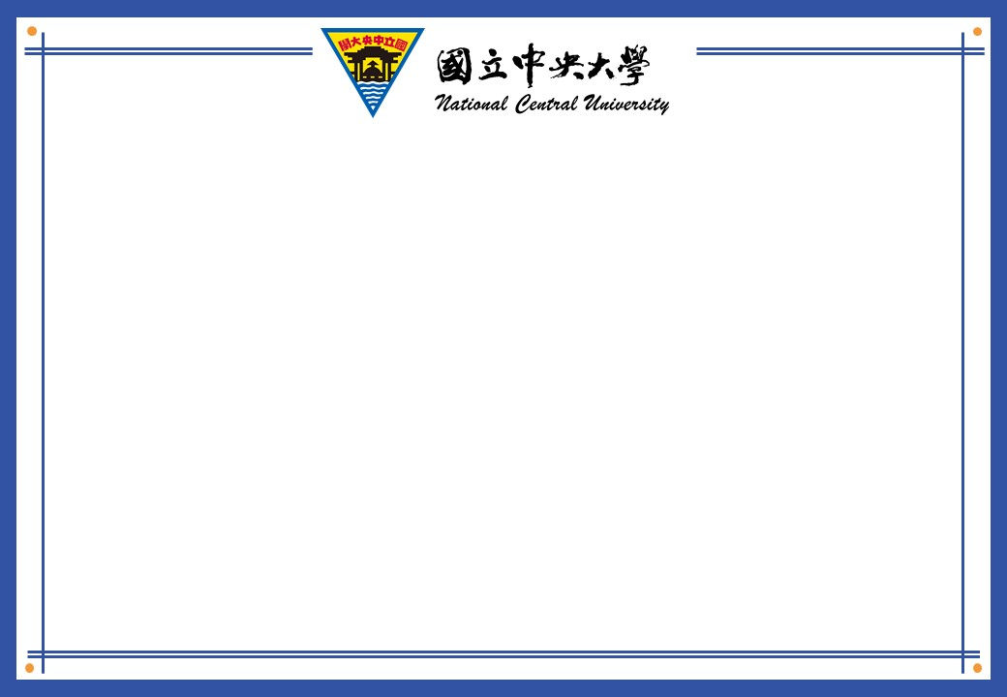

|  |
| --- |
| **修課證明**  CERTIFICATE OF COMPLETION  **本校學生**THIS CERTIFICATE IS AWARDED TO ${name} **，**  **學號**Student ID# : ${cardid}  **目前就讀本校**Majoring in  ${college} ，(學院)  ${dep} ，(系所)  **已完成已下課程修習**Has successfully completed the requirements for the following course:  ${coursedate}  **${coursetitle}**，  **為求慎重，特此證明。**  **CERTIFICATION DATE：${cerdate}** |