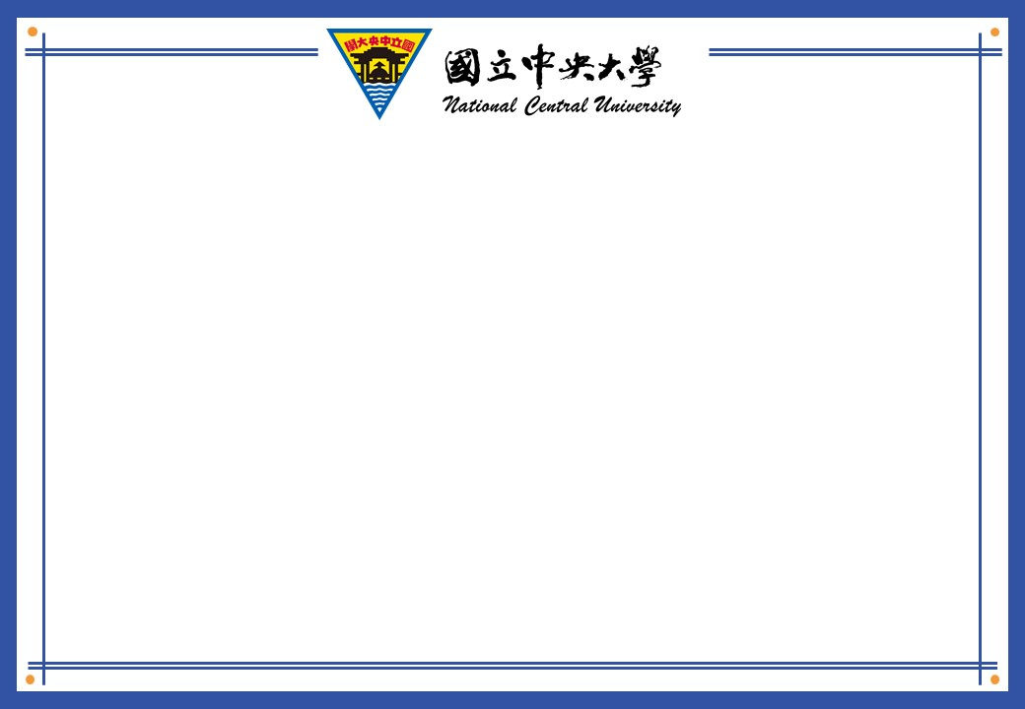

|  |
| --- |
| **修課證明**  CERTIFICATE OF COMPLETION  **本校學生**THIS CERTIFICATE IS AWARDED TO albert **，**  **學號**Student ID# : 6856224444  **目前就讀本校**Majoring in  fanseo ，(學院)  web ，(系所)  **已完成已下課程修習**Has successfully completed the requirements for the following course:  2024-11-25 16:16:00  **測試**，  **為求慎重，特此證明。**  **CERTIFICATION DATE：2024-12-01** |